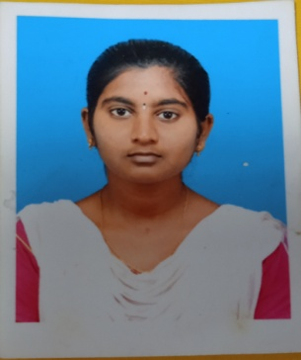**JANANI S**

11/119,Mettu Street,85.R Komarapalayam

Rasipuram, Namakkal – 637 403.

[jananisundaravadivel@gmail.com](mailto:jananisundaravadivel@gmail.com)

9566790771.

**CAREER OBJECTIVE :**

To secure a challenging position in a reputed organization where can expand my learnings and knowledge.

**ACADEMIC QUALIFICATIONS :**

|  |  |  |  |  |
| --- | --- | --- | --- | --- |
| **COURSE** | **NAME OF THE INSTITUTION** | **BOARD OF STUDY** | **CGPA/PERCENTAGE** | **YEAR OF PASSING** |
| BE[Computer Science and Engineering] | Muthayammal Engineering College (Autonomous,Rasipuram) | Anna University | 8.00 | 2024  [pursuing] |
| HSC | Sengunthar Mahajana Higher Secondary School,Gurusamipalayam. | State board | 70.5 | 2020 |
| SSLC | Sengunthar Mahajana Girls Higher Secondary School,Gurusamipalayam | State board | 78 | 2018 |

**TECHNICAL SKILLS:**

**Languages known:**

* JAVA, Python
* HTML, CSS

**Software known:**

* Eclipse, Intellij .

**MINI PROJECTS:**

**Title : Finding Numbers**

* **Objective :** To enable the recognize numbers by their place value and face value.
* **Software Used :** Spring Tool Suite
* **Description :** Different way of writing numbers were brought to use with development of early civilizations .Numbers are used to keep track of time. numbers are involved in buying and selling too. The arithmetic value used quantity and making calculations.

**CERTIFICATIONS:**

* Completed the course on **“Learnathon 2022”** in ICT Academy.
* Completed the course on **“Problem Solving (Basics)”**  Hacker Rank in JAVA.
* Completed the certificate on **“Fundamentals of Artificial Intelligence”** in NPTEL.

**WORKSHOPS & SKILL DEVELOPMENT:**

* Participated National Level Workshop on **“Data Analytics”** in Jabaaj Learning.
* Participated International Level Workshop on “**Internet of Things**” conduceted bt K.S.R. College of Engineering.
* Participated VASD course on **“Data science fundamentals”** in Muthayammal Engineering College.

**INTERNSHIP :**

* Completed the 15 days online Internship on **“Artificial Intelligent and Machine Learning”** in AICL.
* Completed the 8 days Internship on **“Artificial Intelligent”.**

**PERSONAL SKILLS:**

* Self Motivator
* Adaptability
* Willingness to learn

**PERSONAL DOSSIER:**

Parents name : Mr. M. Sundaravadivel , Mrs. S.Bhuvaneshwari.

Date of Birth : 03.01.2003

Blood group : A1B+ve

Nationality : Indian

Languages Known : Tamil, English.

**DECLARATION**

I hereby solemnly declare that the above informations are true and correct to the best of my knowledge and belief.

**DATE :**

**PLACE : [JANANI S]**